Registered Charity No. 228352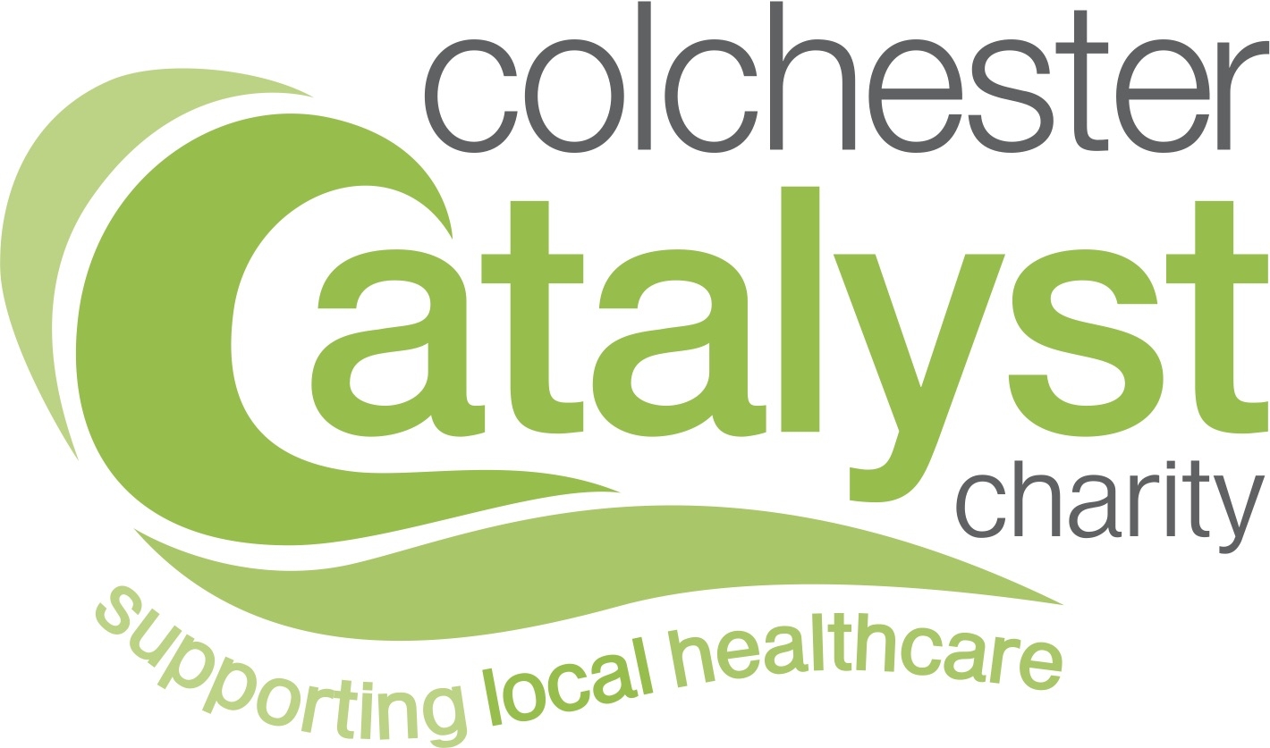

ASSESSMENT OF COMPETENCY TO OPERATE A MOBILITY SCOOTER
OR AN ELECTRIC WHEELCHAIR

Before funding for a scooter/electric wheelchair can be considered by the Colchester Catalyst Charity an assessment needs to be carried out to ensure that a person is safe and competent to operate a mobility scooter/electric wheelchair.

To be completed by the Assessor at The Mobility Centre Please

Name of Assessor

Name of Company

Name of Applicant

Address of Applicant

Type of scooter/electric wheelchair

Has an assessment of competency and safety to drive a scooter / operate an electric wheelchair been carried out recently? Yes/No

Result

Has eyesight been checked? Yes/No

Result

Can the client read a number plate at 40 ft? Yes/No

Insurance must be in place if a grant is agreed.

-2-

Does the person have sufficient mobility in their limbs to be able to operate a scooter / electric wheelchair and to remain on it safely? Yes/No

Has information been given regarding safe storage and battery charging? Yes/No

Has a check been made to ensure that there is suitable storage facilities available to
the client? Yes/No

Does the client fall within the manufacturers’ recommended maximum user weight? Yes/No

Has client’s road awareness been checked? Yes/No

Is the client able to dismantle and lift the equipment into their car? Yes/No

Assessor Signature: ……………………………………………… Date: ………………

(This form must not be completed by the Applicant)

